|  |  |  |  |  |  |
| --- | --- | --- | --- | --- | --- |
| Date | 29-Nov-22 | | | Tester Name | Andrew McLaughlin |
| Environment | Penfax - Test | | | Login used |  |
| Operating System | Select OS | Version: | Update: | | |
| Software Used | Select Software | Version: | Update: | | |
| Select Software | Version: | Update: | | |
| Release version | 22.4.1 | | | | |
| Title | Death – Calculates proper pension amount | | | | |
| Test Type | Regression | | | | |
| Test Scenario | Death – Calculates proper pension amount | | | | |
|  |  | | | | |
| Expected Results | When a pensioner with a joint annuitant dies outside of the guarantee period, an elected portion continues on to their JA.   * The amount should match whatever % they elected. Ex. 60% of $1,000/month becomes $600/month. * This should be reflected in the JA’s Income Benefit. | | | | |
| Pass/Fail | Pass | | | JIRA# | N/A |

Describe your steps with screenshots:

Member is with MEPP and has a bridge 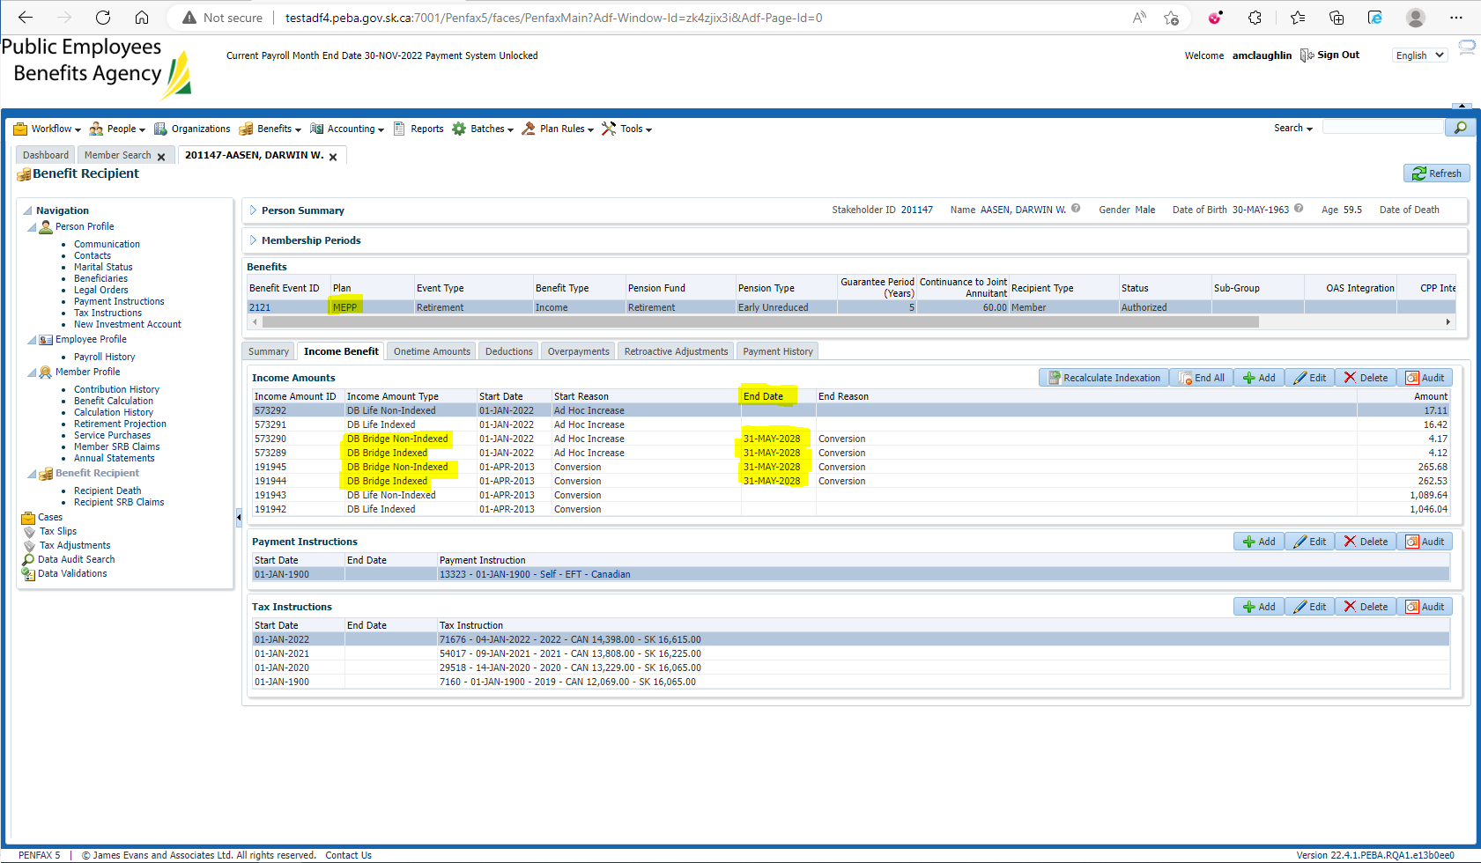

Pension amount is $2,705.71 with a 60% JA. GP Expired 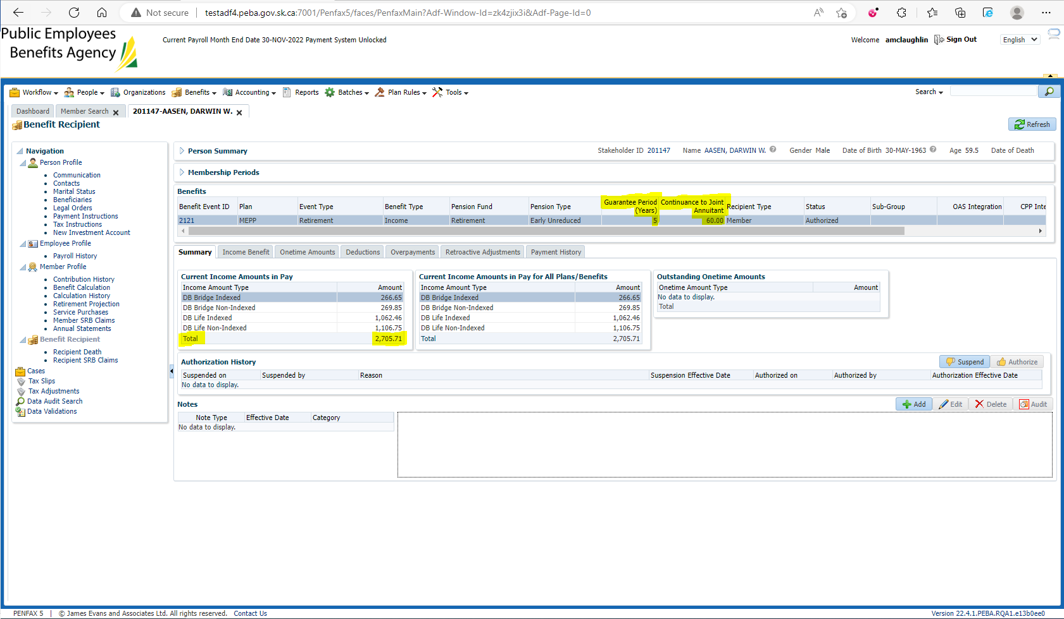

Enter Death Date 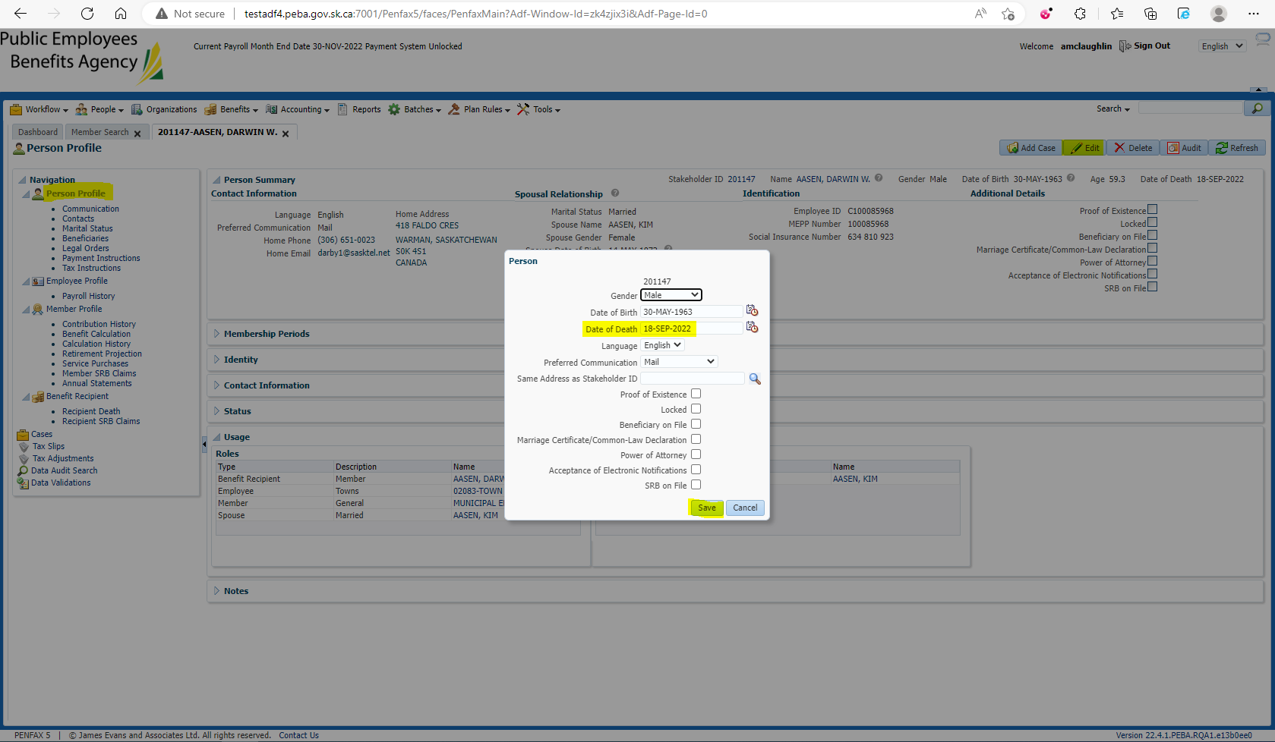

Add the spouse to the Benefit Recipients in the Benefit Event effective 1st day of month after death 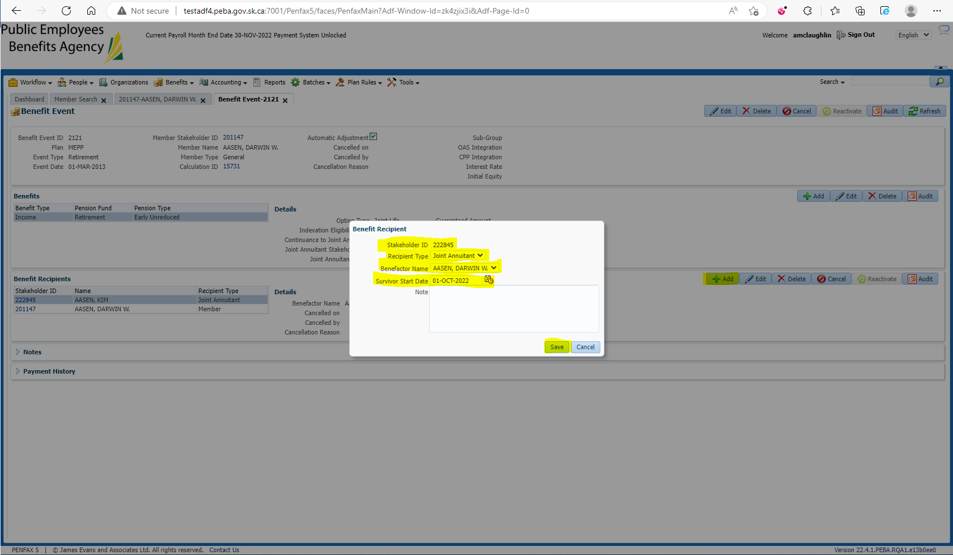

Open the Death Calc 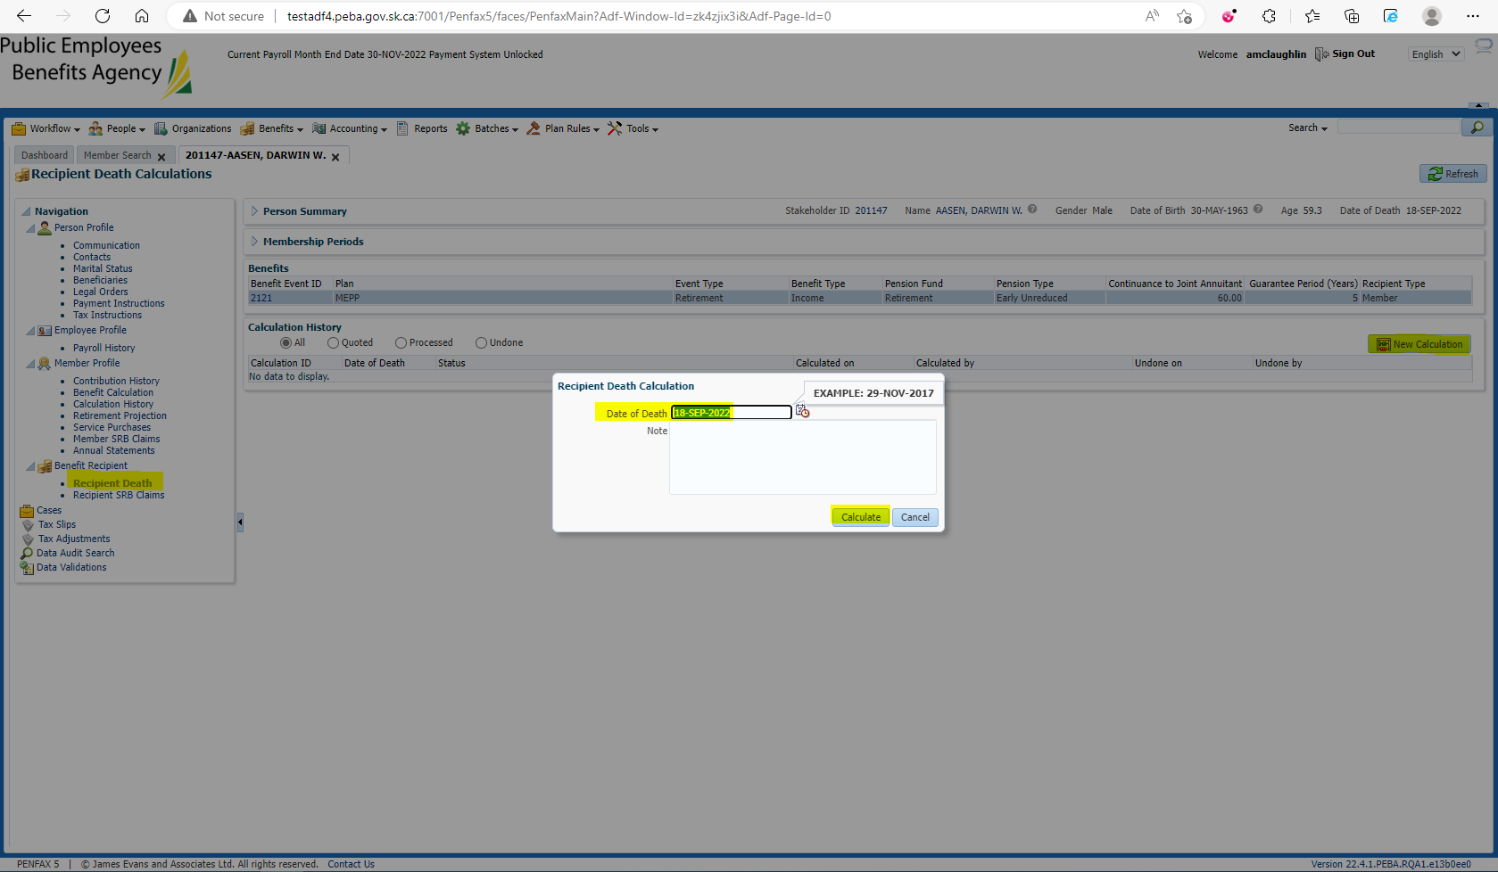

Process x2 and Process Recipient x2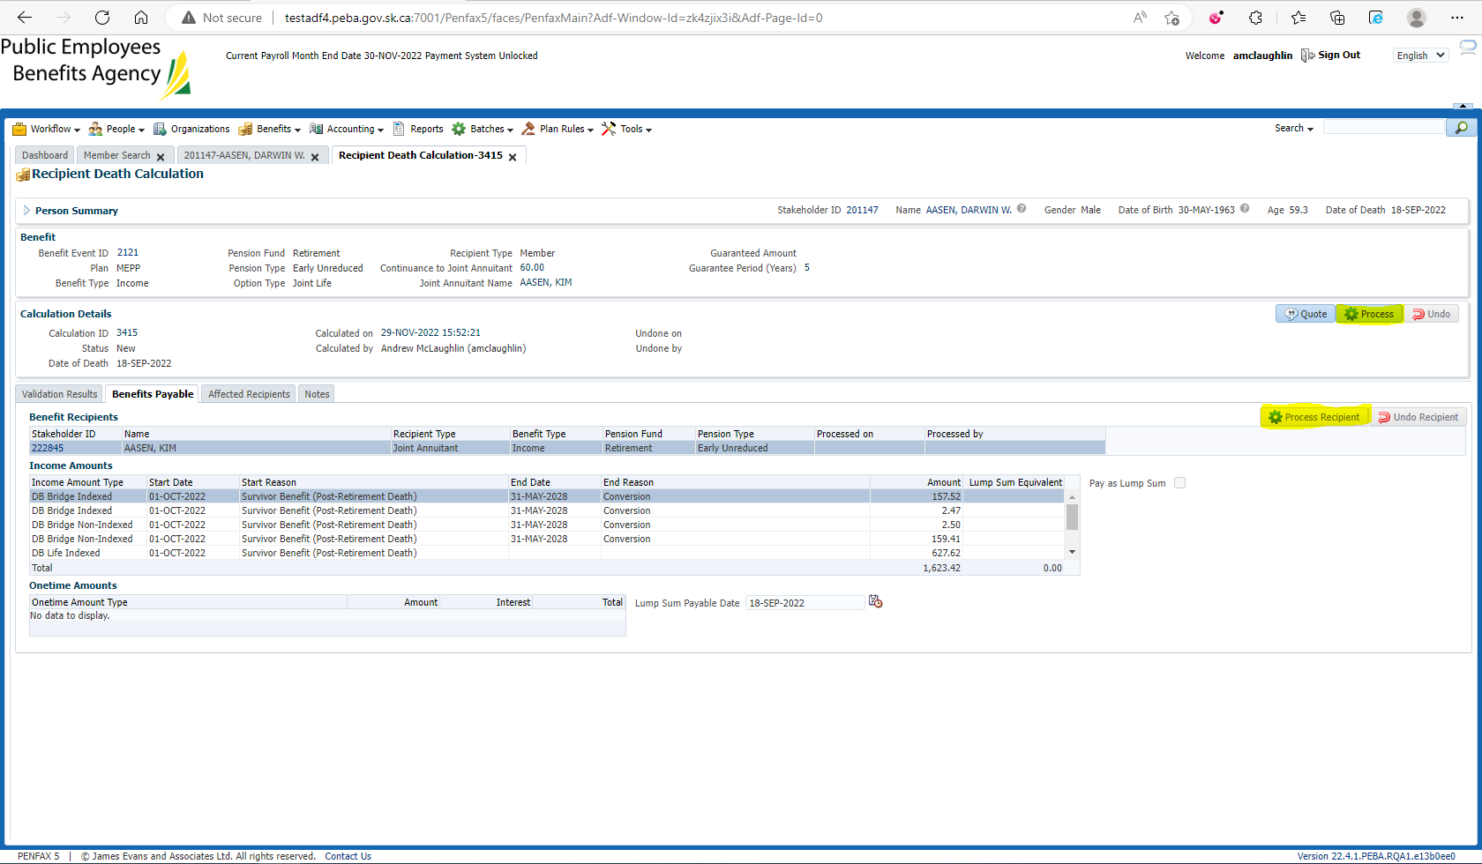

Verify under the spouse’s Benefit Recipient that the pension amount is correct 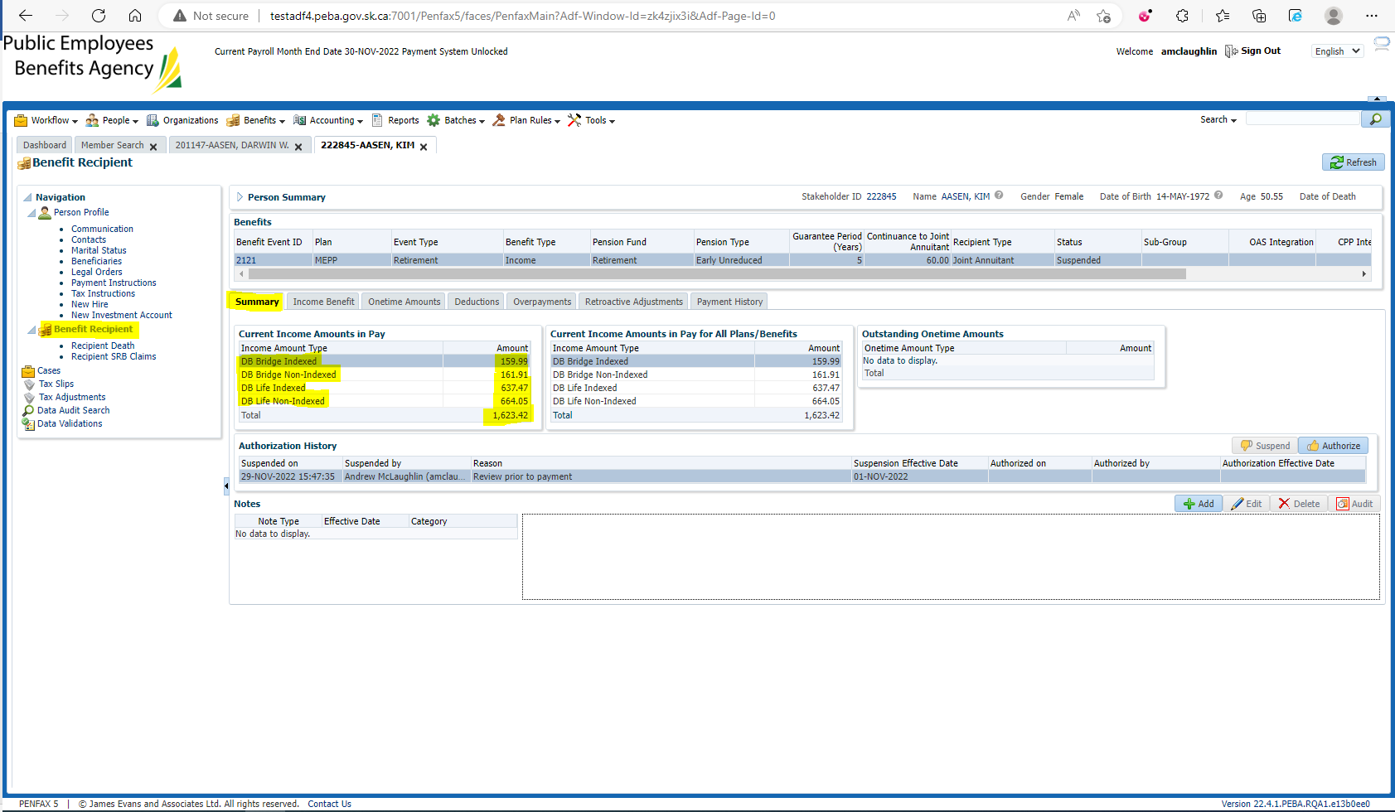

$266.65 * 0.60 = $159.99

$269.85 * 0.60 = $161.91

$1,062.46 * 0.60 = $637.48

$1,106.75 * 0.60 = $664.05